1. Objective
- Understand query processing and optimization in PostgreSQL.
- Apply indexes to speed up data queries.
- Compare query performance before and after creating indexes on a real MRI dataset.

2. Dataset Overview

The dataset MRI contain 6 tables :

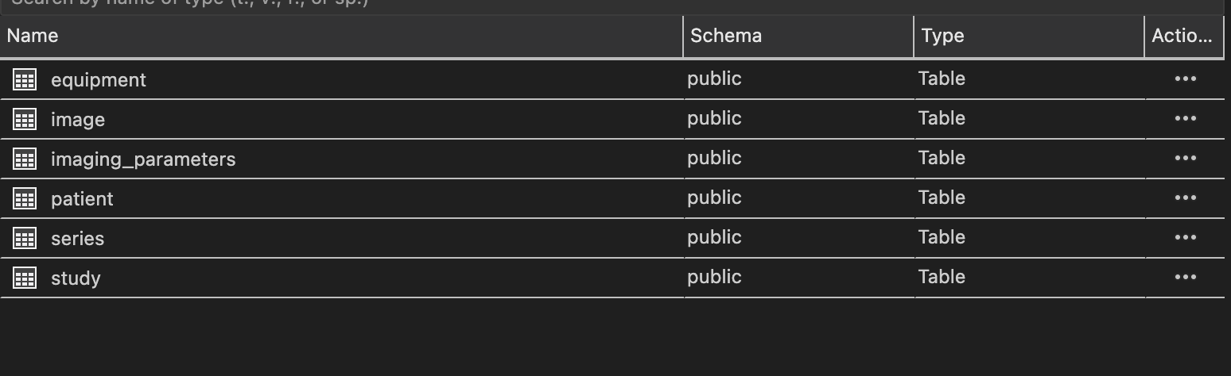

By using SQL code we can get the overview of this dataset
SELECT
relname AS table_name,
pg_size_pretty(pg_total_relation_size(oid)) AS total_size,
reltuples AS row_count
FROM pg_class
WHERE relkind = 'r'
AND relname IN ('patient', 'study', 'series', 'image', 'imaging_parameters', 'equipment')
ORDER BY pg_total_relation_size(oid) DESC;

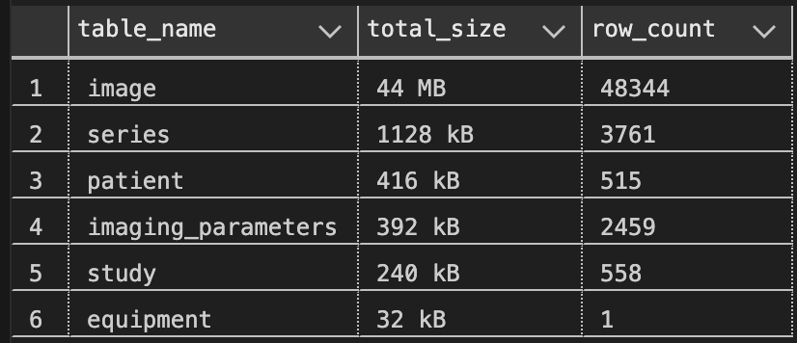

This shows that the image table is the largest → very suitable for testing index optimization because it has many queries that cost I/O.
3. Experiment SetUp
Queries were tested using PostgreSQL with EXPLAIN ANALYZE to measure actual execution time (ms).
Each query was run:
- Before creating index
- After creating index
4. Queries and Optimization
Query 1 – Filter patients by age
-- Before indexing
EXPLAIN ANALYZE
SELECT i.image_id, s.series_id, p.age, p.sex
FROM image i
JOIN series s ON i.series_id = s.series_id
JOIN study st ON s.study_id = st.study_id
JOIN patient p ON st.patient_id = p.patient_id
WHERE p.age BETWEEN 40 AND 60;

-- Create index on patient age
CREATE INDEX idx_patient_age ON patient(age);

-- After indexing
EXPLAIN ANALYZE
SELECT i.image_id, s.series_id, p.age, p.sex
FROM image i
JOIN series s ON i.series_id = s.series_id
JOIN study st ON s.study_id = st.study_id
JOIN patient p ON st.patient_id = p.patient_id
WHERE p.age BETWEEN 40 AND 60;
Query 2: Filter images by patient sex
-- Before indexing
EXPLAIN ANALYZE
SELECT i.image_id, p.sex, st.study_id
FROM image i
JOIN series s ON i.series_id = s.series_id
JOIN study st ON s.study_id = st.study_id
JOIN patient p ON st.patient_id = p.patient_id
WHERE p.sex = 'M';

-- Create index on patient sex
CREATE INDEX idx_patient_sex ON patient(sex);

-- After indexing
EXPLAIN ANALYZE
SELECT i.image_id, p.sex, st.study_id
FROM image i
JOIN series s ON i.series_id = s.series_id
JOIN study st ON s.study_id = st.study_id
JOIN patient p ON st.patient_id = p.patient_id
WHERE p.sex = 'M';
Query 3: Count images per patient
-- Before indexing
EXPLAIN ANALYZE
SELECT p.patient_id, COUNT(i.image_id) AS image_count
FROM patient p
JOIN study st ON p.patient_id = st.patient_id
JOIN series s ON st.study_id = s.study_id
JOIN image i ON s.series_id = i.series_id
GROUP BY p.patient_id;

-- Create indexes for join optimization
CREATE INDEX idx_study_patient_id ON study(patient_id);
CREATE INDEX idx_series_study_id ON series(study_id);
CREATE INDEX idx_image_series_id ON image(series_id);

-- After indexing
EXPLAIN ANALYZE
SELECT p.patient_id, COUNT(i.image_id) AS image_count
FROM patient p
JOIN study st ON p.patient_id = st.patient_id
JOIN series s ON st.study_id = s.study_id
JOIN image i ON s.series_id = i.series_id
GROUP BY p.patient_id;

Query 4 – Find images in a specific study

-- Before indexing
EXPLAIN ANALYZE
SELECT i.image_id, s.series_id
FROM image i
JOIN series s ON i.series_id = s.series_id
WHERE s.study_id = 101;

-- Indexes for study filtering
CREATE INDEX IF NOT EXISTS idx_series_study_id ON series(study_id);
CREATE INDEX IF NOT EXISTS idx_image_series_id ON image(series_id);

-- After indexing
EXPLAIN ANALYZE
SELECT i.image_id, s.series_id
FROM image i
JOIN series s ON i.series_id = s.series_id
WHERE s.study_id = 101;

5. Performance Comparison
Query | Before Index (ms) | After Index (ms)
Query 1 – Filter by age | 51.614 | 26.283
Query 2 – Filter by sex | 50.598 | 34.65
Query 3 – Image count per patient | 31.113 | 30.957
Query 4 – By study_id | 0.055 | 0.050
Observations:
- After creating indexes, PostgreSQL switches from sequential scan → index scan or bitmap index scan.
- Query times drop significantly, especially on large tables like image

7. References
https://www.postgresql.org/docs/current/indexes.html
https://www.postgresql.org/docs/current/using-explain.html
https://www.postgresqltutorial.com/postgresql-indexes/
https://www.cybertec-postgresql.com/en/how-postgresql-query-optimizer-works/

